SIMATS ENGINEERING
ASSESSMENT TOOL 3
COURSE NAME: Database Management Systems
COURSE CODE: CSA05
NAME : YUVANSHANKAR
REG NO : 192511265
COURSE OUTCOME COVERED
CO1: Analyze DBMS architecture, different data models, schema types, and design ER/EER diagrams, relational schemas for case-based scenarios by identifying entities and relationships. (BL1, BL2)
Activity Tool : Technical Presentation (Low) Assessment Tool Weightage: 35%
Dr
QUESTIONS Total Marks: 50
Q.No | Question | Bloom's Level | Marks
1 | Prepare a 5-slide presentation introducing DBMS: definition, objectives, advantages, and real-world applications. | BL2 – Understand | 5
2 | Present a comparison between file-based systems and DBMS using real-life case studies from banking or healthcare. | BL2 – Understand | 5
3 | Deliver a presentation explaining the three-level ANSI/SPARC architecture using diagrams and practical examples. | BL2 – Understand | 5
4 | Present the different data models (Hierarchical, Network, Relational) with diagrams and industry use cases. | BL1 – Remember | 5
5 | Create and present an ER diagram for an Online Library System, explaining each component clearly. | BL2 – Understand | 5
6 | Prepare a presentation on the EER model, demonstrating generalization and specialization with a University case study. | BL2 – Understand | 5
7 | Present the concept of data independence (logical and physical) and its significance in DBMS architecture. | BL2 – Understand | 5
8 | Deliver a technical presentation on the software components of a  DBMS, explaining query processor, storage manager, and | BL1 – Remember | 5
 | transaction manager.
9 | Prepare a presentation comparing strong and weak entities in ER modeling with real-world examples. | BL2 – Understand | 5
10 | Present a complete design walkthrough of an EER diagram for a Retail Chain Management System. | BL2 – Understand | 5

CODE OF CONDUCT:
I __YUVANSHANKAR u(192511265)__________________ (Name / Reg No) certify that this submission is my original work and that I have adhered to the guidelines specified for this assessment. I understand that any violation of academic integrity rules will result in disciplinary action.
Signature of the student:YUVANSHANKAR U
RUBRICS FOR CALCULATION:
Technical Presentation
Criteria | Weightage | Level 4 –  Exemplary | Level 3 – Proficient | Level 2 –  Developing | Level 1 –  Beginning
Technical  Content  Accuracy | 30 | Highly accurate, in-depth, and insightful technical explanation | Technically correct content with adequate depth and clarity | Basic concepts presented with  limited accuracy and depth | Content contains major  technical errors;  concepts poorly understood
Problem  Identification | 25 | Problem rigorously  analyzed using  appropriate and advanced methods | Problem clearly defined with a logical  engineering approach | Problem  identified but analysis or  methodology is weak | Problem statement  unclear or  incorrect; no logical  approach
Use of Tools | 20 | Advanced tools, well-analyzed  data, and highly effective visuals | Appropriate tools and data used  effectively with  clear visuals | Limited use of tools and basic data  interpretation | Minimal or incorrect use of  tools and data;  poor visuals
Communication | 15 | Highly engaging, confident, and audiencefocused delivery | Clear, organized, and professional communication | Understandable but lacks clarity, structure, or confidence | Poor organization,  unclear speech, ineffective slides

Professionalism | 10 | Exemplary professionalism,  leadership, and ethical  awareness | Professional conduct with  effective team collaboration | Basic professionalism;  uneven team participation | Lacks professionalism; minimal  contribution or ethical  awareness

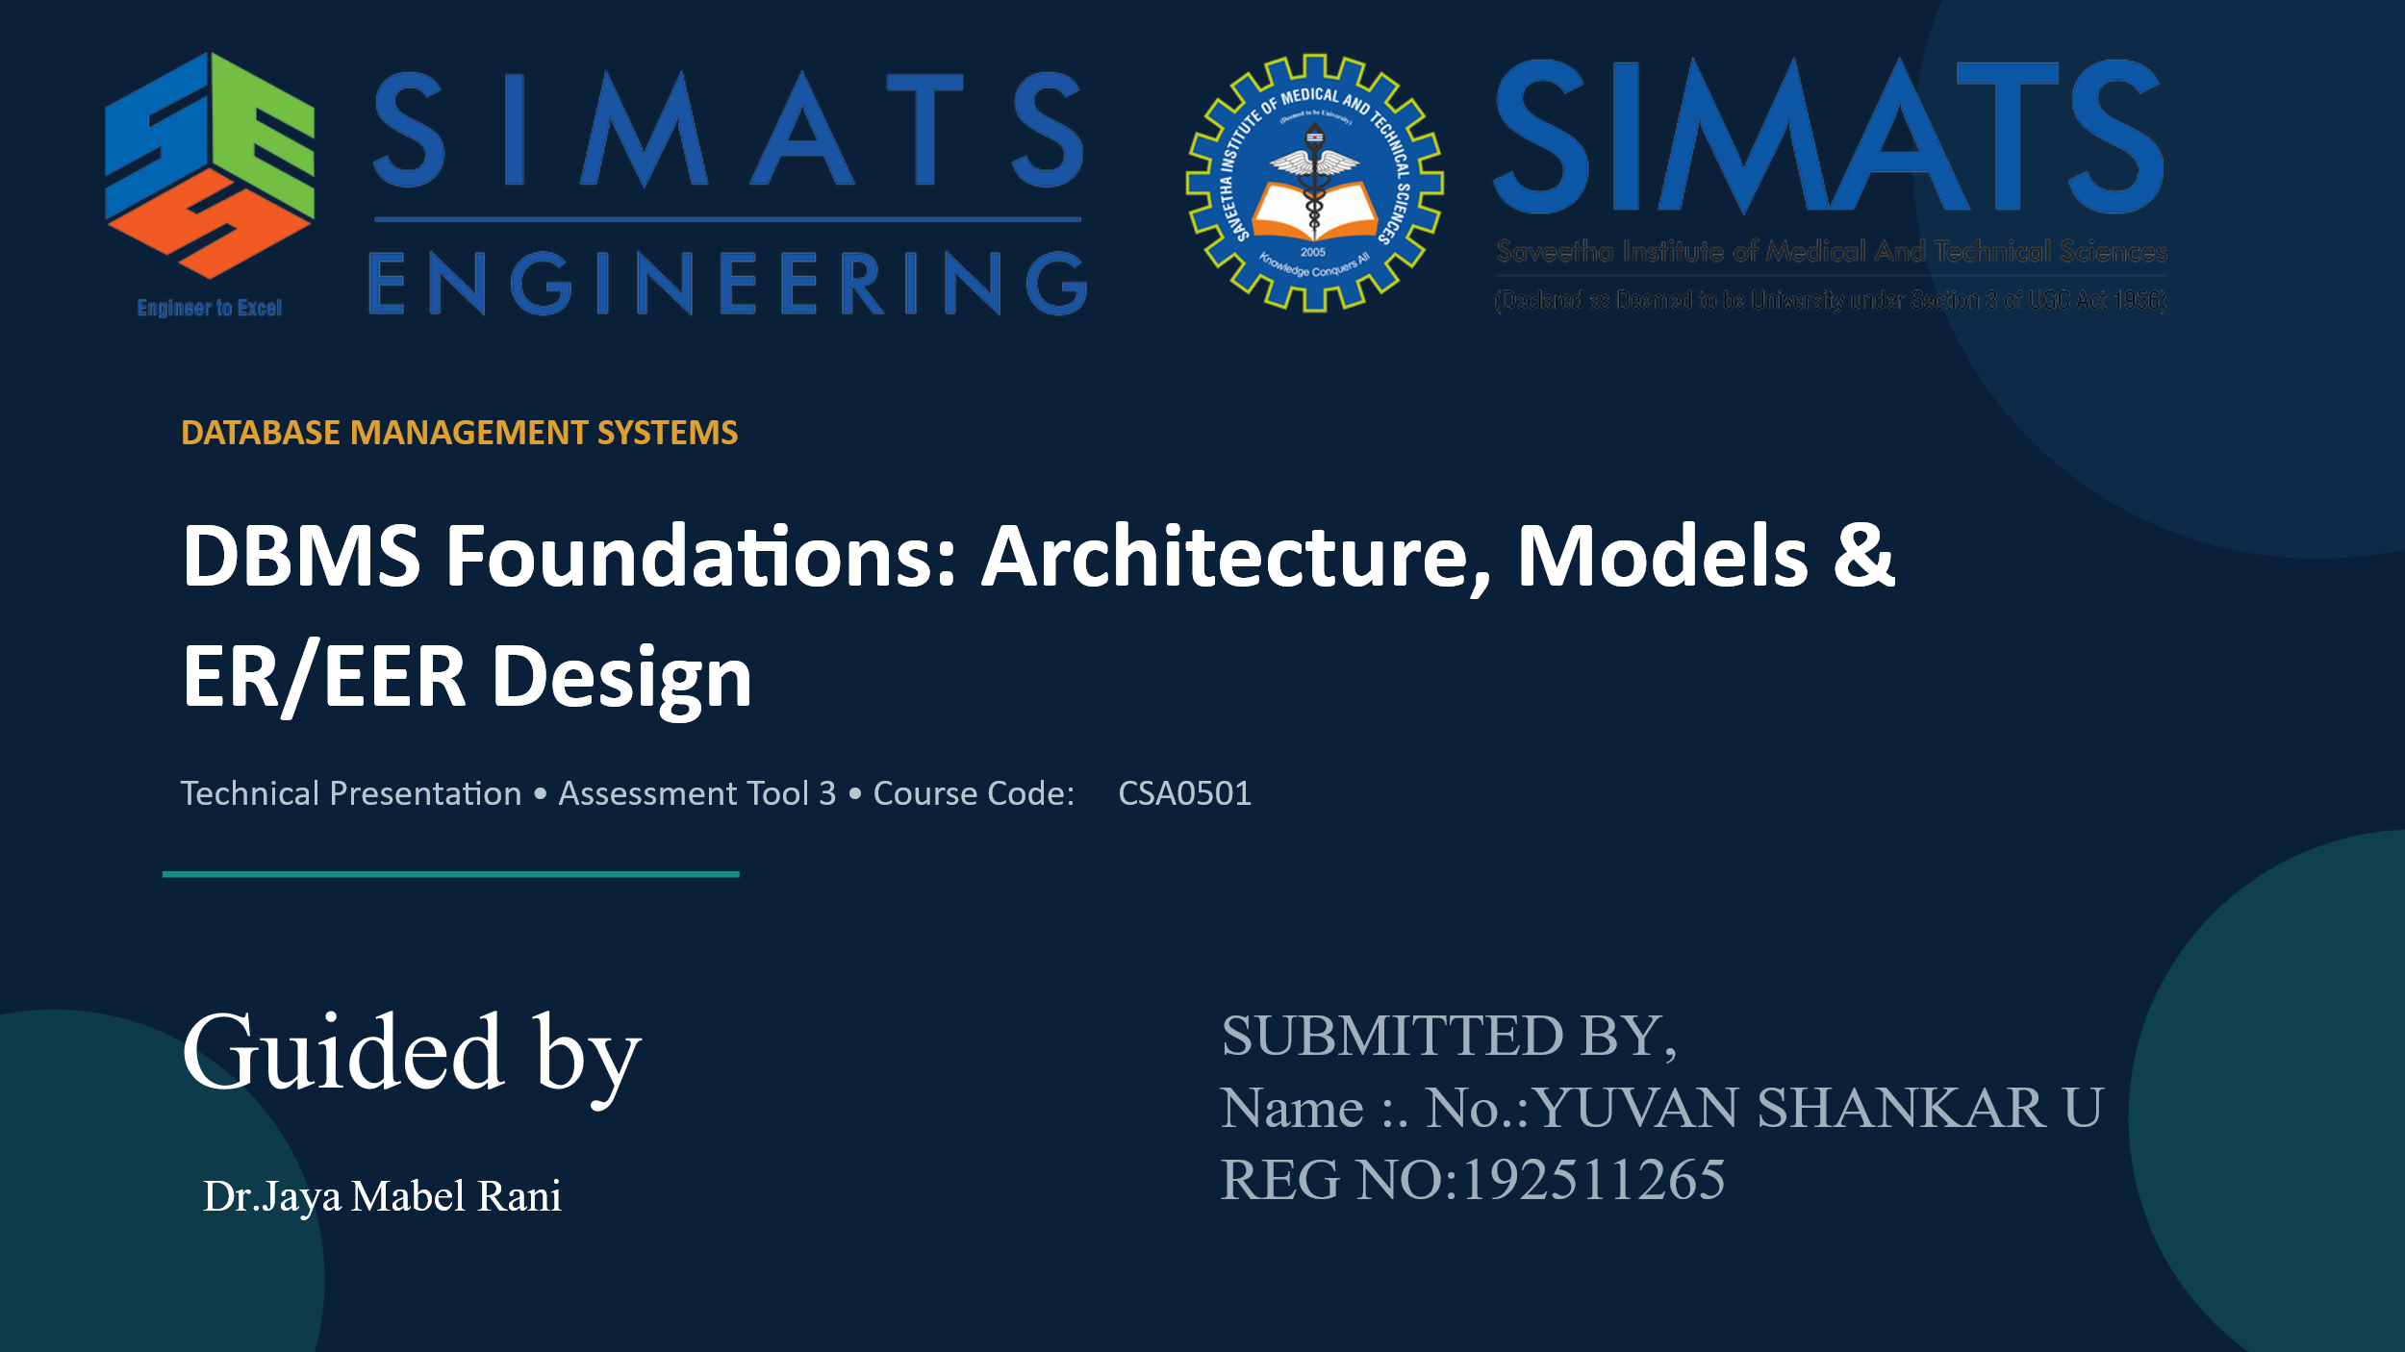

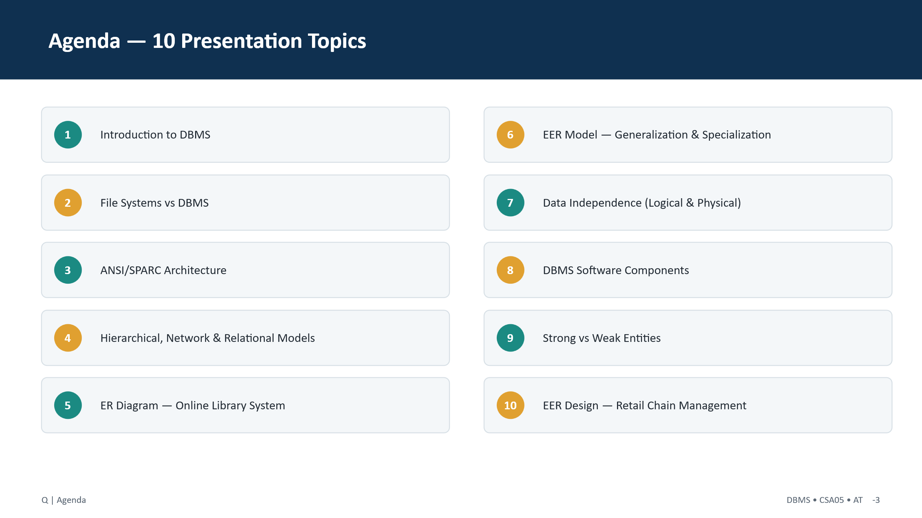2

